Experiment 17：Four bit digital tube
This experiment is the use of Arduino to drive a total of four digital tube. The limit of the flow resistance is essential to drive the digital tube, the current limit resistor has two kinds of connection, a total of 4 D1-D4. This connection is less demand resistance, but will produce a different number of digital brightness will not be the same, 8 of the most dark. This method is the other 8 pin, the brightness of the same, but with more resistance 220 100 8 ohm resistor, so use 220 instead of 10. 0 ohm brightness will be relatively high.
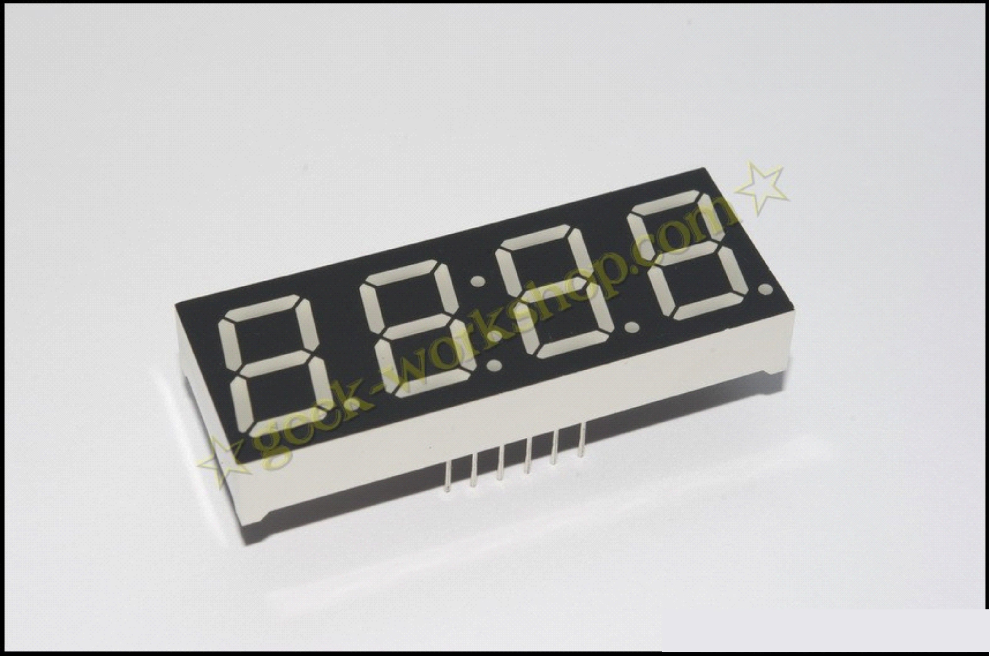
4 digital tube a total of 12 pins, the decimal point is placed in front of the bottom, the lower left corner of the 1, the other pins in the order of the counterclockwise rotation. The upper left corner for the largest 12 pin.
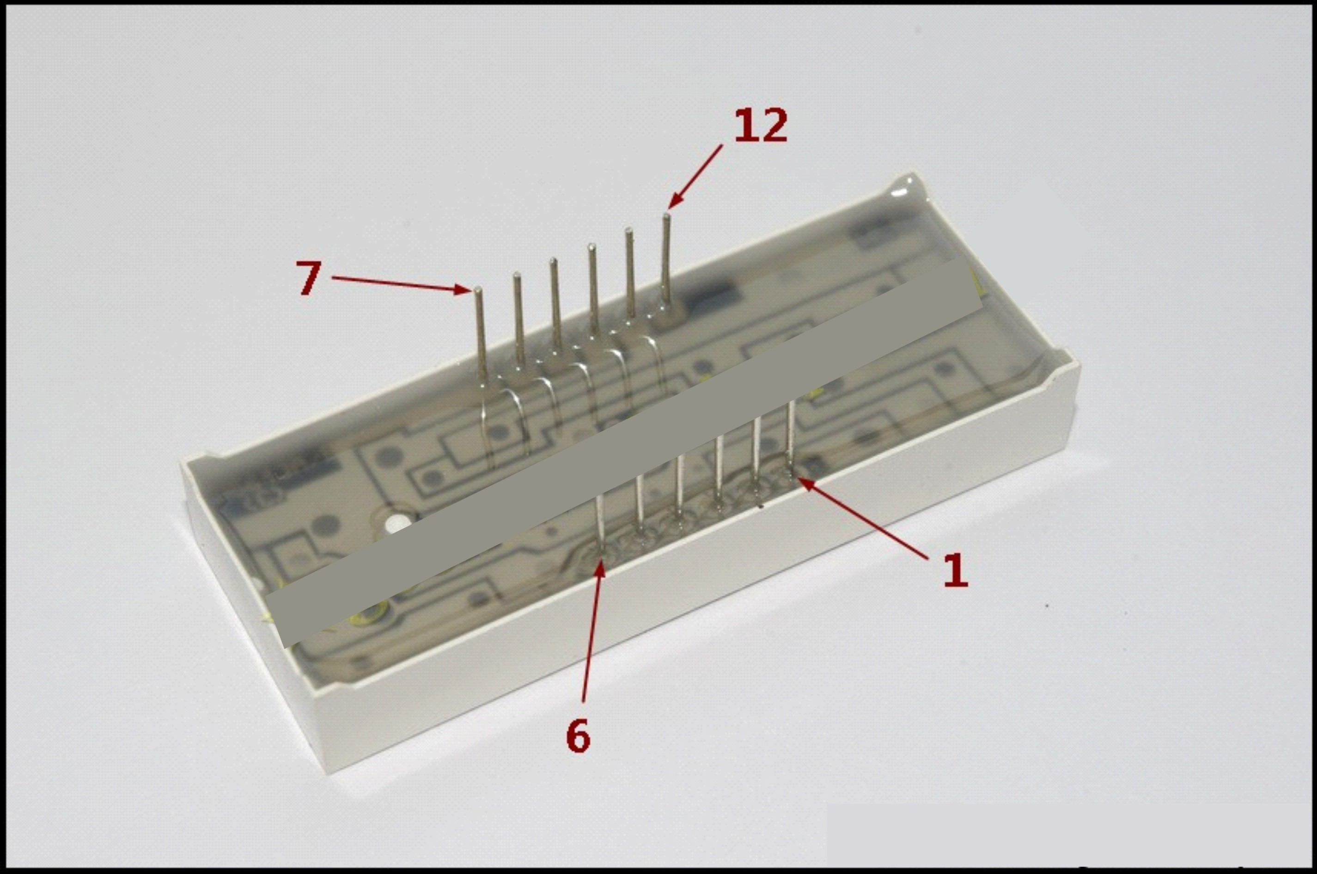
The following figure Manual of digital tube
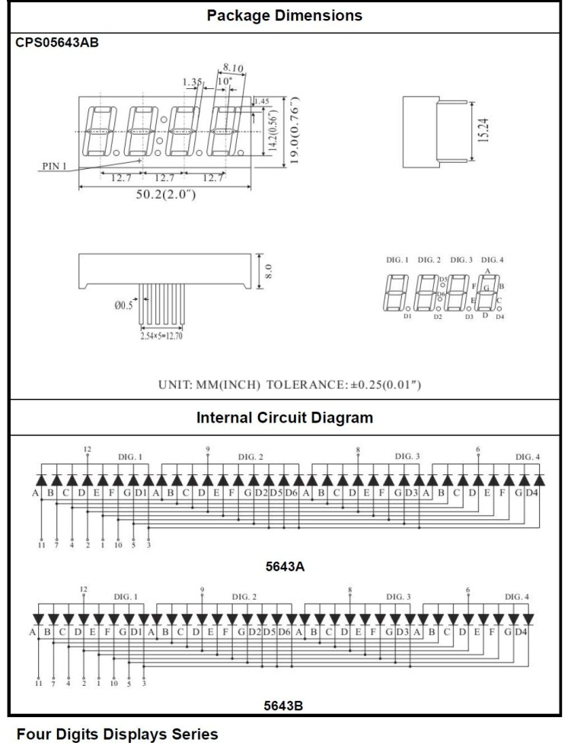

The following is a hardware connection diagram

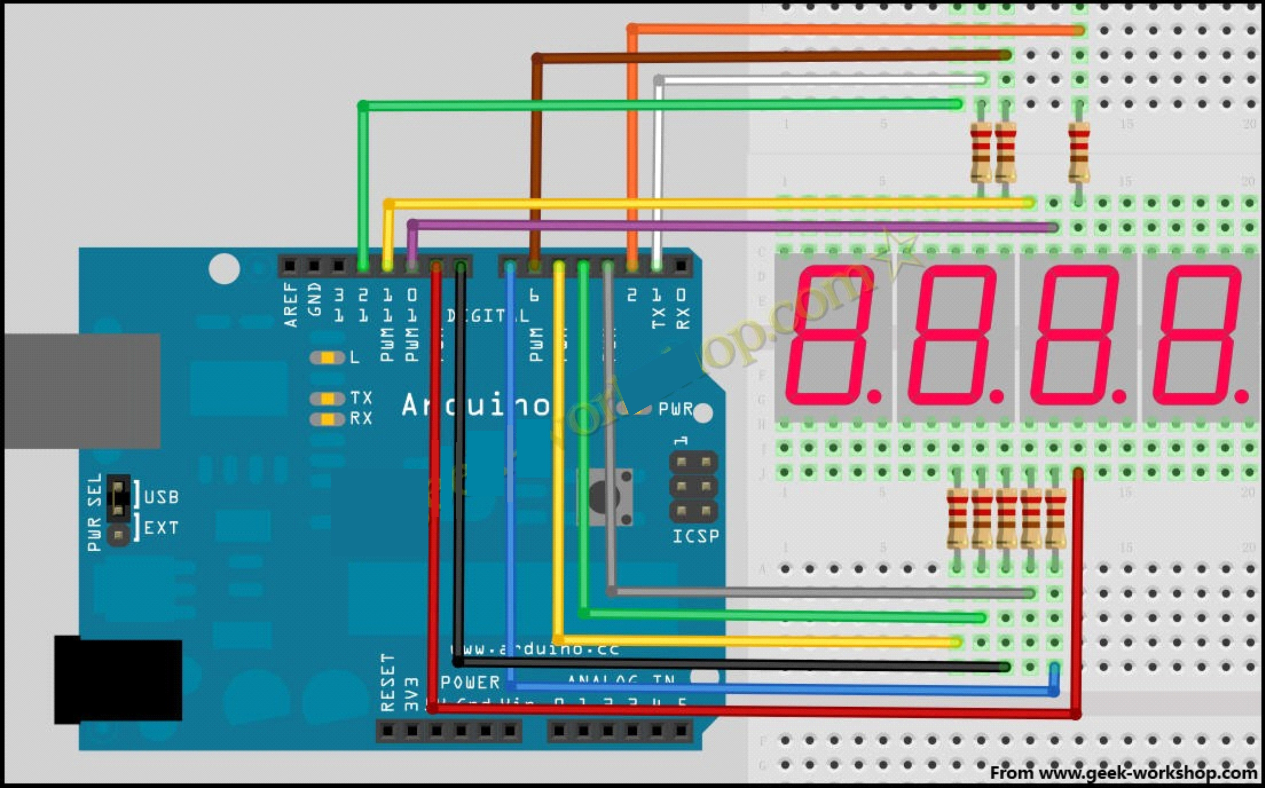
Here is the program；

//display 1234
//Set cathode interface
int a = 1;
int b = 2;
int c = 3;
int d = 4;
int e = 5;
int f = 6;
int g = 7;
int dp = 8;
//Set anode interface
int d4 = 9;
int d3 = 10;
int d2 = 11;
int d1 = 12;
//Set variable
long n = 1230;
int x = 100;
int del = 55; //Here to fine tune the clock
void setup()
{
pinMode(d1, OUTPUT);
pinMode(d2, OUTPUT);
pinMode(d3, OUTPUT);
pinMode(d4, OUTPUT);
pinMode(a, OUTPUT);
pinMode(b, OUTPUT);
pinMode(c, OUTPUT);
pinMode(d, OUTPUT);
pinMode(e, OUTPUT);
pinMode(f, OUTPUT);
pinMode(g, OUTPUT);
pinMode(dp, OUTPUT);
}
/////////////////////////////////////////////////////////////
void loop()
{
Display(1, 1);
Display(2, 2);
Display(3, 3);
Display(4, 4);

}
///////////////////////////////////////////////////////////////
void WeiXuan(unsigned char n)//
{
switch(n)
{
case 1:
digitalWrite(d1,LOW);
digitalWrite(d2, HIGH);
digitalWrite(d3, HIGH);
digitalWrite(d4, HIGH);
break;
case 2:
digitalWrite(d1, HIGH);
digitalWrite(d2, LOW);
digitalWrite(d3, HIGH);
digitalWrite(d4, HIGH);
break;
case 3:
digitalWrite(d1,HIGH);
digitalWrite(d2, HIGH);
digitalWrite(d3, LOW);
digitalWrite(d4, HIGH);
break;
case 4:
digitalWrite(d1, HIGH);
digitalWrite(d2, HIGH);
digitalWrite(d3, HIGH);
digitalWrite(d4, LOW);
break;
default :
digitalWrite(d1, HIGH);
digitalWrite(d2, HIGH);
digitalWrite(d3, HIGH);
digitalWrite(d4, HIGH);
break;
}
}
void Num_0()
{
digitalWrite(a, HIGH);
digitalWrite(b, HIGH);
digitalWrite(c, HIGH);
digitalWrite(d, HIGH);
digitalWrite(e, HIGH);
digitalWrite(f, HIGH);
digitalWrite(g, LOW);
digitalWrite(dp,LOW);
}
void Num_1()
{
digitalWrite(a, LOW);
digitalWrite(b, HIGH);
digitalWrite(c, HIGH);
digitalWrite(d, LOW);
digitalWrite(e, LOW);
digitalWrite(f, LOW);
digitalWrite(g, LOW);
digitalWrite(dp,LOW);
}
void Num_2()
{
digitalWrite(a, HIGH);
digitalWrite(b, HIGH);
digitalWrite(c, LOW);
digitalWrite(d, HIGH);
digitalWrite(e, HIGH);
digitalWrite(f, LOW);
digitalWrite(g, HIGH);
digitalWrite(dp,LOW);
}
void Num_3()
{
digitalWrite(a, HIGH);
digitalWrite(b, HIGH);
digitalWrite(c, HIGH);
digitalWrite(d, HIGH);
digitalWrite(e, LOW);
digitalWrite(f, LOW);
digitalWrite(g, HIGH);
digitalWrite(dp,LOW);
}
void Num_4()
{
digitalWrite(a, LOW);
digitalWrite(b, HIGH);
digitalWrite(c, HIGH);
digitalWrite(d, LOW);
digitalWrite(e, LOW);
digitalWrite(f, HIGH);
digitalWrite(g, HIGH);
digitalWrite(dp,LOW);
}
void Num_5()
{
digitalWrite(a, HIGH);
digitalWrite(b, LOW);
digitalWrite(c, HIGH);
digitalWrite(d, HIGH);
digitalWrite(e, LOW);
digitalWrite(f, HIGH);
digitalWrite(g, HIGH);
digitalWrite(dp,LOW);
}
void Num_6()
{
digitalWrite(a, HIGH);
digitalWrite(b, LOW);
digitalWrite(c, HIGH);
digitalWrite(d, HIGH);
digitalWrite(e, HIGH);
digitalWrite(f, HIGH);
digitalWrite(g, HIGH);
digitalWrite(dp,LOW);
}
void Num_7()
{
digitalWrite(a, HIGH);
digitalWrite(b, HIGH);
digitalWrite(c, HIGH);
digitalWrite(d, LOW);
digitalWrite(e, LOW);
digitalWrite(f, LOW);
digitalWrite(g, LOW);
digitalWrite(dp,LOW);
}
void Num_8()
{
digitalWrite(a, HIGH);
digitalWrite(b, HIGH);
digitalWrite(c, HIGH);
digitalWrite(d, HIGH);
digitalWrite(e, HIGH);
digitalWrite(f, HIGH);
digitalWrite(g, HIGH);
digitalWrite(dp,LOW);
}
void Num_9()
{
digitalWrite(a, HIGH);
digitalWrite(b, HIGH);
digitalWrite(c, HIGH);
digitalWrite(d, HIGH);
digitalWrite(e, LOW);
digitalWrite(f, HIGH);
digitalWrite(g, HIGH);
digitalWrite(dp,LOW);
}
void Clear() //Clear the screen
{
digitalWrite(a, LOW);
digitalWrite(b, LOW);
digitalWrite(c, LOW);
digitalWrite(d, LOW);
digitalWrite(e, LOW);
digitalWrite(f, LOW);
digitalWrite(g, LOW);
digitalWrite(dp,LOW);
}
void pickNumber(unsigned char n)//Choose the number of
{
switch(n)
{
case 0:Num_0();
break;
case 1:Num_1();
break;
case 2:Num_2();
break;
case 3:Num_3();
break;
case 4:Num_4();
break;
case 5:Num_5();
break;
case 6:Num_6();
break;
case 7:Num_7();
break;
case 8:Num_8();
break;
case 9:Num_9();
break;
default:Clear();
break;
}
}
void Display(unsigned char x, unsigned char Number)//Show that x is the coordinate, Number is the number
{
WeiXuan(x);
pickNumber(Number);
delay(1);
Clear() ; //Vanishing
}

Copy the following code to download to the control panel to see the effect chart.
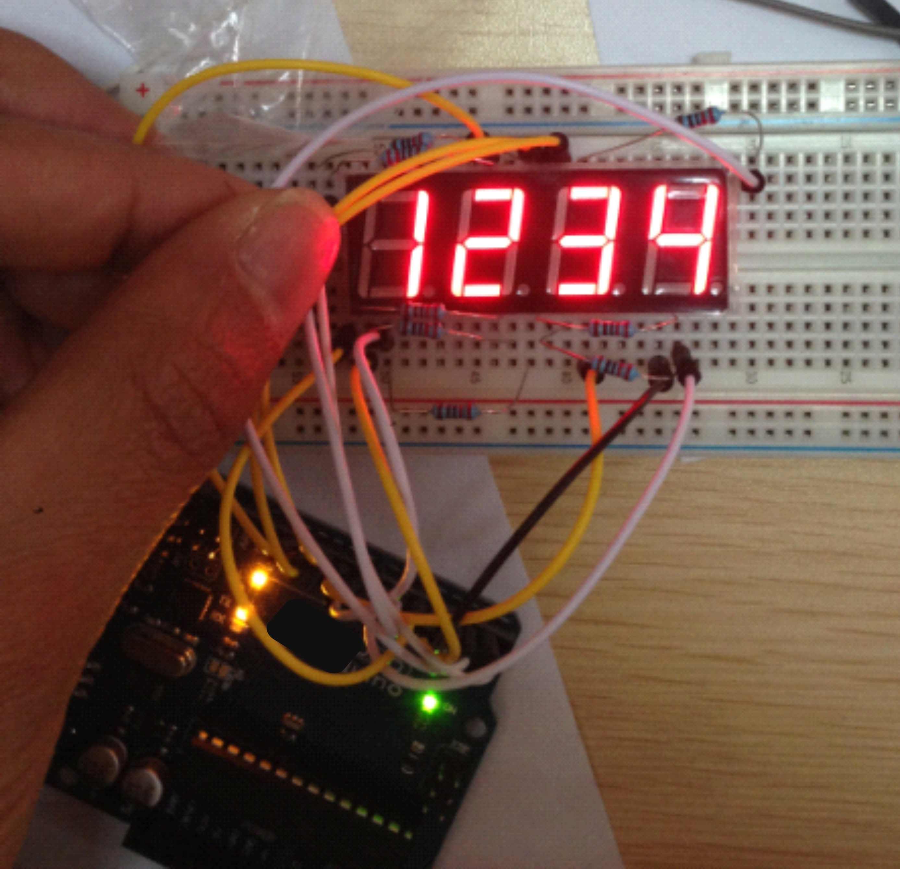

Experimental results for digital tube display 1234,

Note: the connection when the need for patience, careful, not even any wrong line, when garbled, first check the line.

Thank you

